OpenGov Financial Software Navigation Tips for Citizens and Staff
- OpenGov allows you to explore budget and historical finances in a simple graphical user interface.
- You'll notice the title of the chart or graph you are viewing in the top left corner.
- You can use the Show drop-down to see the data that is of most interest to you.
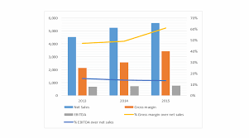
- Use the Broken Down By drop-down to specify the category you would like the data organized by in your chart or graph.
- Select the Filtered By option to view the data filters. These filters will allow you select exactly which data you want to include, or exclude, from your graph or chart.
- Use the Search function within each filter to find exactly what you are looking for.
- There are five different types of visual representations of the data:
  - A stacked percentage graph to see percentage changes over time
  - A stacked line graph to visualize overall trends over time.
  - A line graph overlaying each trend over time.
  - A pie chart to view percentage breakdowns by year.
  - A bar chart comparing trends and percentage breakdowns over time.
- Below any chart or graph, you can view a Table detailing the financial information in the visualization above.
- Use the Help drop-down in the top right corner to:
  - View a short How-To Guide with tips on navigating the platform.
  - Recall the Welcome Screen.
  - View a short Budget 101 primer with basic information on multi-fund accounting.
  - Contact the administrators of the account.
- Use the Share drop-down in the top right corner to:
  - Share your customized graph or chart through social media.
  - Send a link to your customized graph or chart through email.
- Use the Download drop-down in the top right corner to:
  - Download an image of the graph or table as a .png file.
  - Download a spreadsheet as a .csv file.

